|  |
| --- |
| University of toronto |
| Developing Instruments to Facilitate Endoscopic Ear Surgery |
| Thesis Progress Report |
|  |
| **Arushri Swarup** |
| **10/5/2017** |

|  |
| --- |
|  |

## Literature Review:

### Endoscopic Ear Surgery:

#### Ear surgery:

Middle ear surgery is a type of ear surgery, or otological surgery, that is done to repair the ear drum (tympanoplasty), hearing bones (ossiculoplasty) and remove tumors (cholesteatoma) that grow within the middle ear and mastoid. Traditionally, ear surgery is performed by making a postauricular incision, as shown in , to access the middle ear space and uses a microscope to visualize the surgical field. This is an invasive method of surgery and results in a scar and longer hospital stay for the patient.

#### Microscopic vs. Endoscopic Ear surgery:

Endoscopes provide direct access and a wide angle view into the middle ear, reducing the time required to gain access, drill bone for exposure and close during middle ear surgery and are able to visualize hidden recesses within the middle ear including: the sinus tympani, anterior and posterior epitympanum and hypotympanum [1][2][3][4]. As well, the endoscope allows visualization past the shaft of the instrument, such as the drill, which is a problem during microscopic surgery[5]. shows the difference in operating room setup and view of the endoscope vs. the microscope.

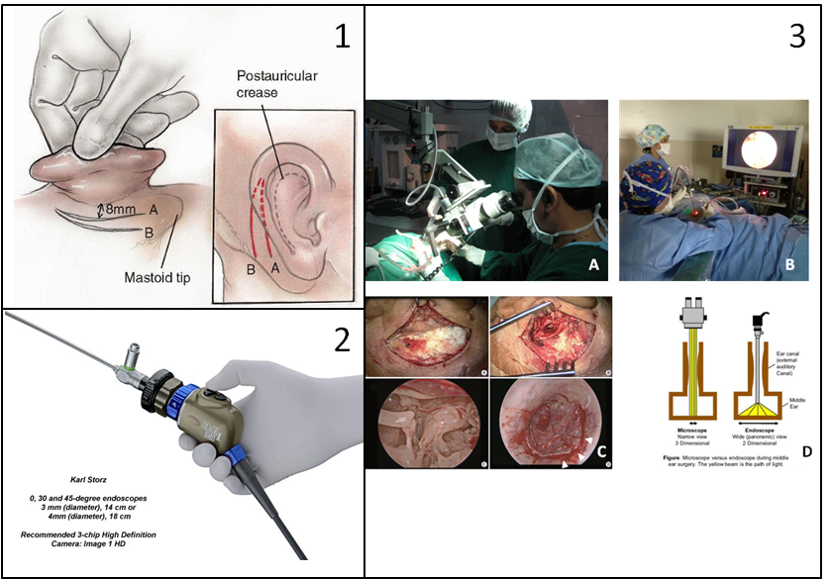

Figure 1: Panel 1 shows the slits made to access the middle ear for invasive microscopic ear surgery [6]. Panel 2 shows an endoscope that is attached to a high definition camera, which is used to visualize the surgical field during TEES [7]. Panel 3: The top two images (A&B) show the difference between the operating room setup for microscopic ear surgery and endoscopic ear surgery [8], [9]. The bottom two images (C&D) show the difference in view between microscopic and endoscopic approaches. C is from Choi et al. who shows the difference in view between microscopic (top two squares of C) and endoscopic ear surgery (bottom two squares of C). The figure on the right shows the difference in field of view between microscope (left square of D) and endoscope (right square of D) [10], [11].

Despite the enthusiasm of some otologists, endoscopic ear surgery has a low adoption rate[12][13].  The principal challenge with TEES is that a one-handed surgical technique is required as the endoscope is held in the other hand[12][9]. During traditional surgery, the non-dominant hand usually maintains suction and removes blood from the operative field while the dominant hand performs the delicate maneuvers [9]. Otologic instruments were developed for two-handed microscope-guided surgery so they are not optimized for the TEES environment. As otologists have been trained and gained experience in microscope-guided ear surgery, they have developed techniques with the according instruments and have become accustomed to a two-handed surgical approach. By learning different surgical techniques and gaining experience with the endoscope, most surgeons find that they can complete more cases totally endoscopically [14][12][1][9].

Technological advances in the design of the endoscope, camera and suction dissection instruments have lead to incremental stepwise jumps in this learning curve [3]. In order to further develop technology and instruments to facilitate TEES, it is important to understand the specific challenges experienced during TEES. It is proposed that in order to facilitate TEES, the needs of surgeons and current limitations of tools must be determined.

The two types of middle ear surgery that are focused in this project are cholesteatoma removal and tympanoplasty. Cholesteatoma is an abnormal skin grown that occurs behind the ear drum (tympanic membrane) inside the middle ear and its growth can damage the ossicles and/or facial nerve and cause temporary or permanent hearing loss. TEES to remove cholesteatoma is challenging because the tumors are usually located in areas that are visible through the endoscope but inaccessible via current straight and rigid tools, thus requiring the surgeon to drill bone to access those areas with straight tools. Tympanoplasty is the reconstruction of a perforated ear drum, by placing a synthetic (animal-derived) or cartilage graft on it. It is challenging to maneuver and position the graft using TEES.

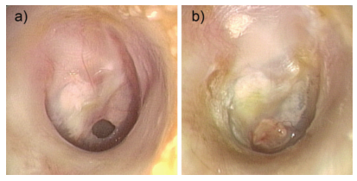**Figure 2:** These images, taken from James et al., are endoscopic photographs. (A) shows a perforated ear drum and (b) shows the postoperative result, 2 months after tympanoplasty surgery that used a cartilage graft [15].

<INSERT PICTURE OF CHOLESTEATOMA>

### TEES Instrumentation:

Talk about these instruments as a ‘survey’/overview of what’s already on the market

Then talk about the instruments that Dr. James uses for TEES – Panetti, Karl Storz set

Daniele used the ultrasonic bone cutting (demonstration at the TEES course in October)

David Pothier uses the standard Karl Storz ear surgery kit (no suction)

Good overview of currently existing tools for TEES: “ Ins t rumen ta tion and Technologies in Endoscopic Ear Surgery”[3]

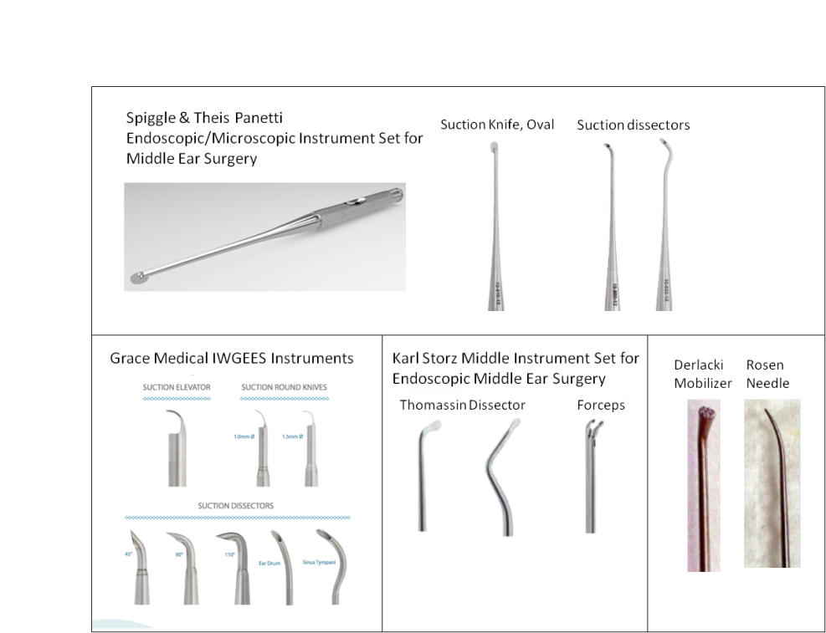**Figure 3:** These are different sets of endoscopic ear surgery instruments. The Spiggle & Theis Panetti set incorporates suction along the shaft of its instruments in order to allow for two functionalities, suction and dissecting or suction and cutting, in one tool, eliminating the need to switch between a suction instrument and dissection instrument or knife [16]. Grace Medical and Karl Storz have similar suction capabilities but the PI has preferred the curves of the Panetti set [17], [18]. Many instruments have a curve at the tip in order to reach the middle of the endoscopic field of view, which does not occur for straight-shaft instruments as the ear canal constricts the movement of instruments. The Thomassin dissector, Derlacki Mobilizer and Rosen Needle are frequently used by the PI to position grafts and dissect tissue as their respective tip shapes are preferred to manipulate tissue effectively. The Rosen Needle tip curvature allows for dissecting tissue that is attached to the ear drum as the tip shape compliments the curvature of the ear drum, and when the needle is rotated axially, the tip follows a trajectory which is useful to manipulate tissue without having to translate the tool which would cause the instrument shaft to collide with the endoscope or ear canal wall.

These instruments are valuable to the principal investigator (an otologist), particularly the Panetti Set that incorporates suction within the shaft of a curved instrument. However, the PI has expressed that through his experience with these rigid curved and straight instruments, he is still unable to reach around corners within the middle ear space, where cholesteatoma is visible but not reachable with existing instruments. This requires the surgeon to remove bone from the patient in order to access the areas to remove the cholesteatoma. A steerable instrument with an articulating tip would be able to reach these hard-to-access areas and would make it possible for the surgeon to remove cholesteatoma within the recesses of the middle ear without taking away excess bone.

#### Steerable Mechanism: Wrist

The CIGITI lab develops notched tube compliant wrists which define the underlying mechanism of the controllable flexible instrument, see . It is a one degree of freedom compliant joint machined or laser cut into a nitinol tube. Nitinol is a superelastic material that is used for this application as the material properties allow it to bend into a curve and return elastically to its original shape, i.e. with no plastic deformation of the tube. Notches in the tube allow the wrist to have greater flexibility and the notch geometry can be customized to achieve the desired arc length and radius of curvature. The controllable flexible instruments presented here have a rectangular notch geometry and a compliant contact aided mechanism geometry. The paper presenting these wrists “Design of a Contact-Aided Compliant Notched-Tube Joint for Surgical Manipulation in Confined Workspaces” was co-authored by myself and is to be published in the ASME Journal of Mechanisms and Robotics.

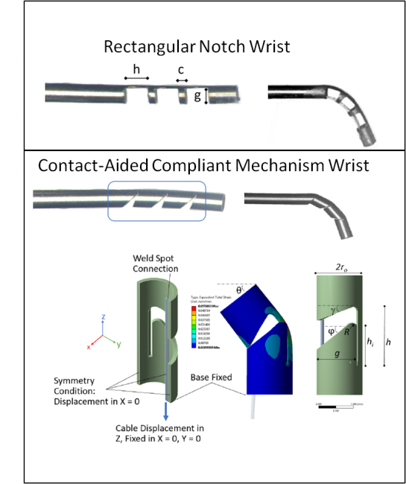**Figure 4:** Eastwood et al. describes the two wrists that are presented in this report. The top panel shows the simple, rectangular notched wrist geometry. This is the geometry used for manufacturing prototype 1. The bottom panel shows the contact-aided compliant notched tube, which was laser cut into a nitinol tube to manufacture prototype 2. A cable is attached at the ‘weld spot connection’ and pulling on the cable (downward as shown in the image) causes the joint to bend.

#### Robotic Steerable Instrument for Middle Ear Surgery:

Yasin et al. presents a robotic tool that aims to allow middle ear surgeons to perform precise tasks and access hard to reach anatomical targets using a custom-designed robot that controls grippers that are attached to a shape-set nitinol tube with a fixed radius of 7.5mm at the tip [21]. The nitinol ‘cannula’ can be retracted into a stainless steel ‘stem’ and when the tool needs to reach something, the cannula extends out of the stem to curve and reach the target. This is similar to the controllable flexible instrument due to the curved tip that can be manipulated however, the robotic instrument’s tip radius of curvature cannot be adjusted to reach the desired target, i.e. cholesteatoma hidden behind tight corners like the sinus tympani. This concentric tube robot technology is also developed by the lab, however, the notched tube wrist was chosen as the articulating mechanism due to its compactness and smaller radius of curvature achievable that is required to reach around corners inside the miniature anatomy.

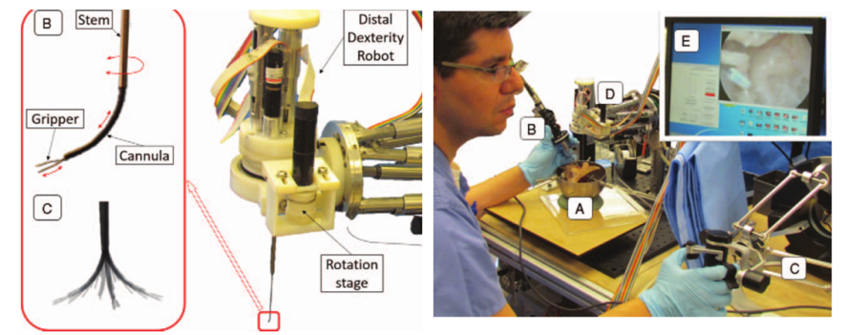**Figure 5:** Yasin et al. developed a steerable robot-assisted micromanipulation device for the middle ear. The left panel shows the robot with the tool extending downward out of it, and the right panel shows the surgeon teleoperating by gripping the ‘distal dexterity robot’. The gripper consists of forceps, attached to the cannula which is a nitinol tube which is shape set to a permanent radius of curvature of 7.5mm. The cannula can retract into the stem where the instrument assumes a straight position. As the cannula extends out of the stem, the tip assumes a curved shape [21].

#### Steerable Instrument Handle Design:

By watching the PI perform TEES cases and interviewing the PI and his colleagues at the 2016 Endoscopic Ear Surgery Course in Toronto, it was determined that a tool that can be held like current instruments would be best suited for the new TEES instrument as the surgeon would not have to learn anything new and would be able to easily adopt the new tool. The goal of the new TEES instrument would be to help the surgeon perform TEES, not frustrate them into learning how to maneuver and manipulate a new instrument. There are many steerable instruments on the market, two of which are shown in Figure 7. These are instruments where the handle design would be suitable for the new TEES instrument; the TEES instrument handle is similar to the vitreoretinal laser probe as it is gripped like current instruments in a pen grip, which allows the surgeon to precisely control fine movements at the tip of the tool, which is necessary to avoid damaging structures within the confined regions of the middle ear. Both types of handles were prototyped, see Figure 7.

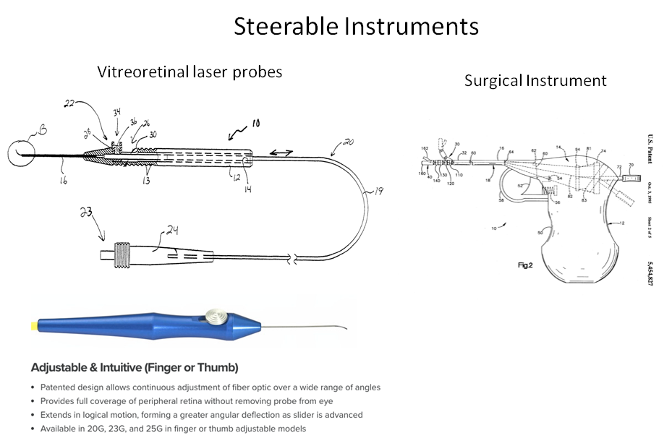Figure 6: This is a steerable vitreoretinal laser probe which is used to deliver laser energy to the retina for therapy. The slider at the handle allows the surgeon to push out the preshaped 90o nitinol tip [19].

# Objectives/Hypotheses

TEES requires a one-handed surgical technique as the endoscope is held by the other hand, which is very challenging for surgeons. Current instruments have been designed for the two-handed traditional microscopic invasive surgical technique. This project aims to design and evaluate a new instrument that would address the challenges faced by endoscopic ear surgeons. To do this, the project is composed of two phases: phase one is the needs analysis study which surveyed experienced otologists about instruments they would like to be developed. The needs analysis study showed that the challenge that needs a better instrument to the greatest degree is reaching structures visualized by the endoscope. Phase two is developing and testing a prototype instrument to reach structures within the middle ear that are visualized by the endoscope.

## Phase 1: Understanding the Needs of Endoscopic Ear Surgeons

Please refer to the attached paper to be submitted to the journal: Otology and Neurotology within the next month: “The Current Limitations and Future Direction of Instrument Design for Totally Endoscopic Ear Surgery: A Needs Analysis Survey.”

## Phase 2: Prototype Development and Testing:

From the needs analysis study, developing a controllable flexible instrument that can reach areas visualized by the endoscope would be addressing the greatest difficulty for TEES surgeons.

### Requirements:

These requirements will be used to evaluate the tool and if it is appropriate to meet the functional requirements as well as be used during TEES. ** make sure this aligns with the survey for REB

|  |  |  |  |  |
| --- | --- | --- | --- | --- |
| Requirements: | Metric: | Prototype 1 | Prototype 2 |  |
| Functional Requirements: | | | | |
| Reach areas visualized by the endoscope | PASS/FAIL | PASS |  |  |
| Reach hard-to-reach areas such as the sinus tympani, boundaries of the antrum | PASS/FAIL | PASS |  |  |
| Tip stiffness |  |  |  |  |
| Tip can dissect tissue |  |  |  |  |
| User Requirements (Criteria): | | | | |
| Easy to control (grip and ergonomics of handle) | Surgeon feedback (rating) |  |  |  |
| Easy to use (grip and ergonomics of handle) | Surgeon feedback (rating) |  |  |  |
| Feels like an existing tool |  |  |  |  |
| Constraints: | | | | |
| Fit alongside the endoscope | PASS/FAIL |  |  |  |
| Fit inside the ear canal |  |  |  |  |
| Sterilizability |  |  |  |  |

*** include the virtual model renders that show that the endoscope and tool do not collide with the ear canal wall.

## Prototype Development:

There are two phases of prototype development thus far: prototype 1 of the controllable flexible instrument was presented at the 2nd World Congress for Endoscopic Ear Surgery in Bologna, Italy in April, 2017. It showed otologists the proof of concept that a controllable, flexible manually-operated instrument can reach structures visualized by the endoscope that are difficult to reach with conventional instruments. The next phase was to add functionality to the flexible instruments, such as dissection, laser, suction and study patient anatomy to determine the wrist parameters to achieve reach in the appropriate areas. The second phase of prototypes consist of instruments that have incorporated suction, laser fibre and dissection at the tip and aim to be presented at the Sentac 2017 Annual Meeting on pediatric otolaryngology and will be submitted to the IEEE Engineering in Medicine and Biology Conference, 2018.

### Proof of Concept Prototype:

**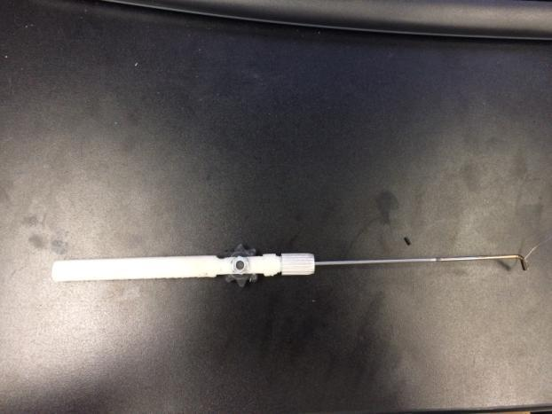****Figure 7:** The pen-style prototype requires the surgeon to grip the instrument similar to how they grip current tools during middle ear surgery, like a pen. This prototype is the basis of the next generations of the prototype. The handle design was conceived by developing a way to pull on the cable actuating the wrist while encased inside an instrument handle of similar size to current instruments. To tug on the cable, a slider or a wheel would be simple to actuate and the wheel took up less space and less movement of the fingers so that was decided.

The size of the handle was determined by developing a virtual model that integrated the endoscope, TEES instrument prototype and temporal bone anatomy model of a patient to compare the size of the tools and ensure they would not collide with each other.

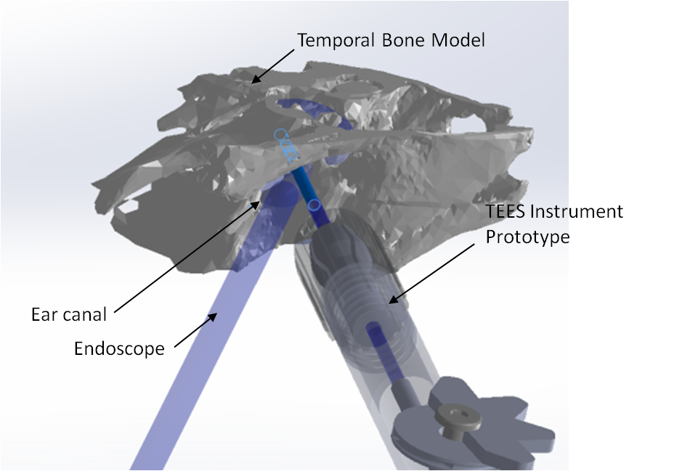Figure 8: Virtual model integrating temporal bone anatomy from a patient, an endoscope and the TEES instrument proof of concept prototype. This virtual model was able to guide the size of the instrument handle such that the shaft would be able to fit inside the ear canal without colliding with the endoscope or the ear canal and the handle would not collide with the endoscope.

When the handles were tested by the PI, he preferred the pen-style handle because: the grip was most similar to current instruments, it could be rotated axially to adjust the tip orientation without hitting moving so much as to collide with structures within the middle ear, and this grip allows for easier and more precise control of the tip.

### Manufacturing Prototype 1 – Controllable Flexible Instrument

The wrist was manufactured using a CNC MicroMilling Machine <machine spec/description> to cut notches in a nitinol tube, OD = 1.24mm, ID = 1.03mm. This tube was chosen as its ID is greater than the ID of a 19 gauge sucker, which is the smallest diameter sucker that has enough suction power. A simple initial rectangular notch pattern was milled as a first test prototype. The nitinol wrist was soldered to a stainless steel shaft that is clamped in a collet, using a collet clamp, at the distal end of the handle. The handle was machined so the collet clamp can be threaded onto the distal end and there is room for the finger piece to rotate. The cable, soldered to the tip of the wrist, runs along the tube and is clamped in the finger piece.

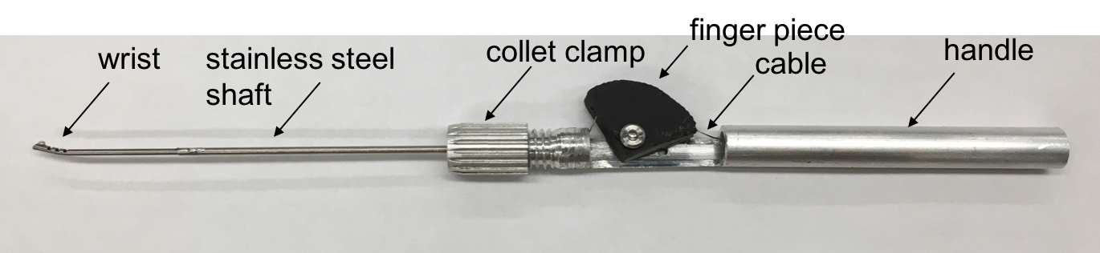

Figure 9: Version 1 prototype of the controllable flexible instrument. The wrist consists of notches milled into a nitinol tube, connected to a stainless steel shaft that is clamped onto the handle that consists of a finger piece that controls the cable displacement of the cable attached to the nitinol wrist. Moving the finger piece back causes cable displacement and thus wrist actuation.

### Testing Prototype 1 of the controllable flexible instrument:

#### Reaching sinus tympani:

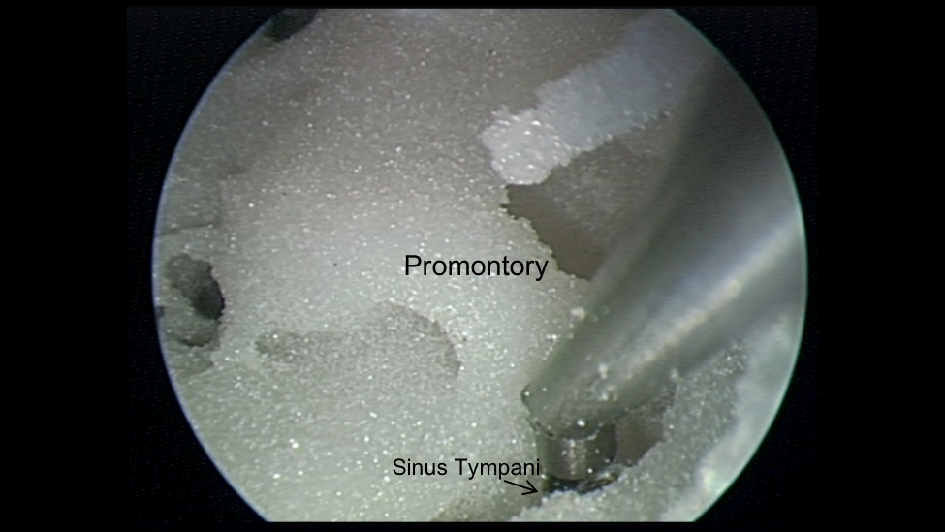Figure 10: This is a model of the left temporal bone. The promontory is a landmark bone inside the middle ear, behind the ossicles. The sinus tympani is shown and is very difficult to reach into with standard, rigid tools to dissect and remove cholesteatoma. Often, the cholesteatoma is visualized in the sinus tympani with the endoscope but the tools cannot reach inside to extract it. This image shows, with an endoscope view, that the controllable, flexible instrument can reach into the sinus tympani.

#### Dissecting the tegmen:

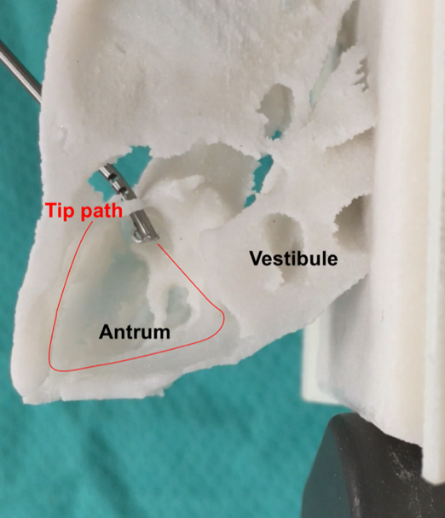Figure 11: This is a model of the left temporal bone. The model has been cropped so that the antrum is visible in this bird’s eye view. Cholesteatoma had eroded the ear canal in this patient like an atticoantrostomy, a hole in the ear canal where the instrument is coming through. Thus, the instrument is introduced through that opening and the tip can reach and dissect the boundary of the antrum.

### Manufacturing Prototype 2:

After testing the initial prototype, the next step was to finalize the design of the wrist such that it will reach the areas of interest within the middle ear during TEES. The geometry of the wrist needed to be designed to narrow down an appropriate range for radius of curvature and arc length of the wrist. A simple experiment was conducted to narrow down the arc length of the wrist required to reach difficult to reach areas within the middle ear. Fichera et al. described the process they used to create a steerable endoscope which is < 2mm in diameter with a notched nitinol tube wrist with an HD camera mounted on the tip [22]. They designed this to inspect the middle ear space by going through the Eustachian tube accessed through the nose [22]. In order to determine the appropriate parameters of the steerable tool: endoscope diameter, length, required curvature, they generated 3D models of patient middle ear space by CT scan image segmentation. On these models, target points where the endoscope needed to reach were identified and the optimal path to reach the target was computed using a computer software developed by the research group. These paths identified to reach the target maximized visual coverage of the sinus tympani (area where cholesteatoma generally recurs), calculated the associated bending angle and arc length – calculation shown in reference [2] of the paper. They used a nitinol tube which is larger than the proposed tool (OD = 1.8mm, ID = 1.6mm) which validates that this tube size will fit inside the middle ear space.

* sinus tympani anatomy: D. Marchioni, S. Valerini, F. Mattioli, M. Alicandri-Ciufelli, and L. Presutti, “Radiological assessment of the sinus tympani: Temporal bone HRCT analyses and surgically related findings,” Surg. Radiol. Anatomy, vol. 37, no. 4, pp. 385–392, 2015.

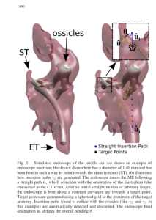

* From 6 high res CT scans

To determine the approximate, appropriate range of motion for the proposed tool to reach in difficult to reach areas within the middle ear during TEES, a simplified, modified approach, inspired by the Fichera et al. study was used. The range of arc length and radius of curvature needed to be identified. The PI provided 9 CT scans from patients with with difficult TEES anatomy where bone had to be removed to access the cholesteatoma to remove it. The CT scans were segmented using Materialise Mimics and 3-Matic image segmentation software. 3D models of the patients’ temporal bone were rendered and within these, specific anatomy: the sinus tympani and antrum were identified, see Figure XXX.

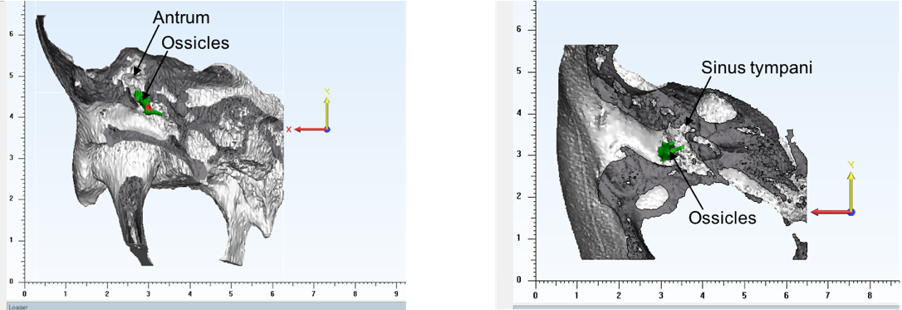

Figure 12: 3D virtual model of temporal bone anatomy used to identify structures for the new tool to reach.

Add the instrument range of motion 2d paper study thing.

The next step was to determine the range of arc lengths for the new tools. The radius of curvature is bound by the outer radius of the tube: minimum radius of curvature = 2*outer diameter of tube. Based on this, a sketch of the range of articulation for the tool from minimum radius of curvature to straight was rendered for different arc lengths. These were printed in 2D and overlaid to determine the appropriate arc lengths to reach the targets. A smaller arc length yields a stiffer tip, which is desirable for dissection and better control of the instrument.

|  |  |  |
| --- | --- | --- |
|  | **Radius of Curvature (Rc)** | **Arc Length (s)** |
| Min | Rcmin = 2*Ro = **1.24mm**  Smin = minimum arc length  Ro = outer radius of NiTi tube | S = rθ  S = 1.24*3pi/4 = **2.92mm**  To achieve bending angle = 135deg. To reach the boundary of the 0deg endoscope field of view |
| Max | S=Rc*θ  Rc = s/θ = 7.5/(3*pi/4) = **3.18mm** | **7.5mm**: distance between promontory (bony boundary of middle ear) and tympanic spine* |

Dahm et al. reported the anatomical measurements on 60 cadaver specimens, and reported that the average distance between the promontory and tympanic spine is 7.48mm for all specimens and this distance doesn’t change with age [23]. This describes the maximum arc length that is limited by the anatomy of the middle ear as this is the distance between the endoscope at the medial end of the ear canal where the middle ear begins and the promontory which is the boney wall of the middle ear (???). Using Matlab, a randomly distributed of 10 arc lengths was generated to span the range 2.92-7.5mm and these were used to generate a 2D sketch of the workspace/reaching area of a wrist with that arc length sweeping from radius of curvature 1.24 mm to straight. These were superimposed on the cross sections of the 3D models to select the parameters for the next prototypes.



<https://image.slidesharecdn.com/2-151023145818-lva1-app6892/95/anatomy-of-middle-ear-4-638.jpg?cb=1445612510>

The tool will be manufactured for sterilizability and using medical grade materials for all parts. At this stage of the project, however, a proof of principle prototype has been constructed and does not comply by the necessary ISO 13485 standards for medical devices.

Furthermore, the handle and thumb piece will be further developed in the future for ergonomic design and this design will be informed by user feedback.

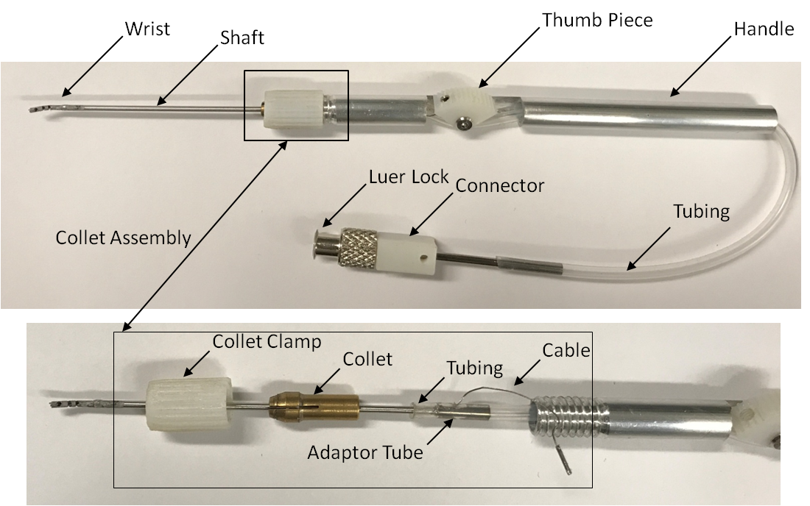

Figure 13: Outlines the components in the suction tool prototype.

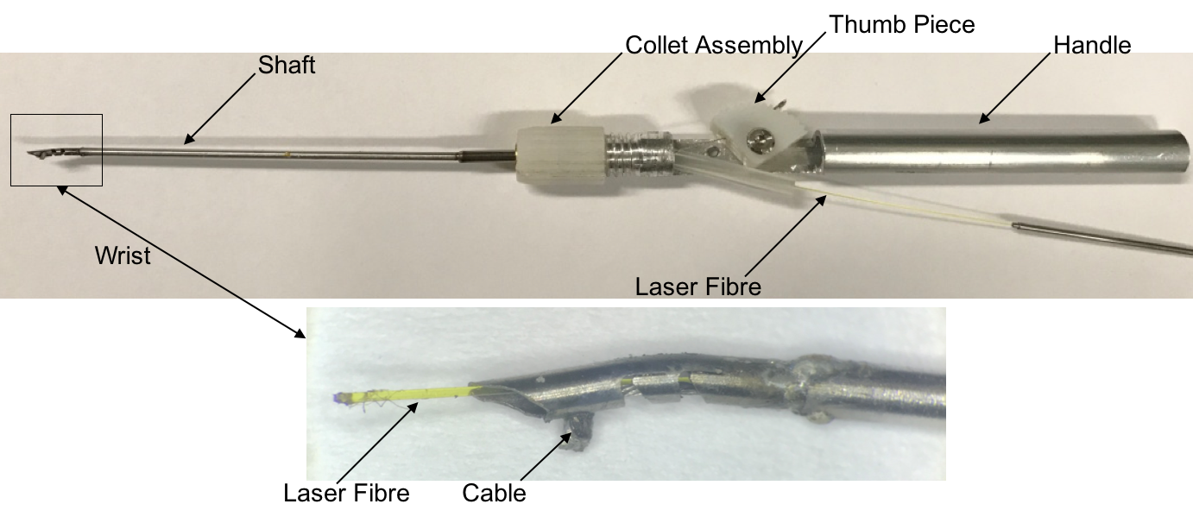

Figure 14: Outlines the components in the laser fibre tool prototype.

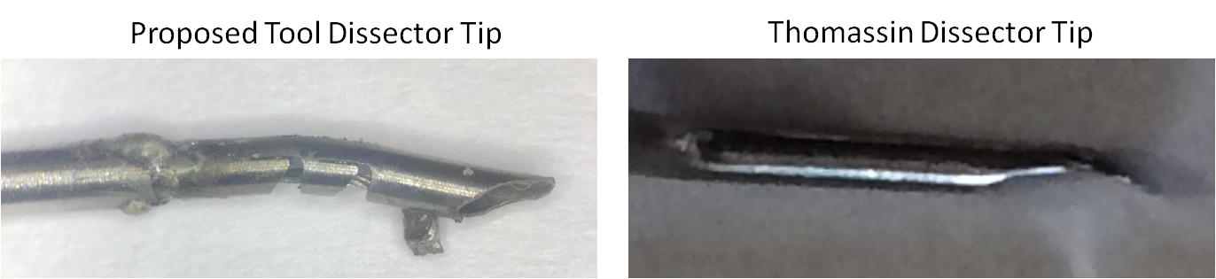

Figure 15: Shows a zoomed in view of the dissector tip, inspired by the Thomassin Dissector Tip.

Rosen needle curvature is perfect to reach within the field of view of the endoscope – not the case for straight instruments and when you rotate it axially the tip makes a trajectory which is convenient as other instruments you have to translate and then they would hit the boundaries of the ear canal.

## Future Work:

### Testing tools:

#### Suction Testing:

The suction capabilities will be tested by measuring the flow rate of the proposed tool vs. a conventional suction instrument. As well, the suction functionality will be tested by users inside 3D printed anatomical temporal bone models.

#### User Feedback Testing:

The goal of this testing will be to finalize the range of arc lengths for the tool to achieve the desired reach, using patient anatomy.

##### Test One: Target Reachability

Goal: quantify reachability. Temporal bone models will be 3D printed where the targets, determined by the PI, to be reached by the instrument tool tip will be coloured. Using an endoscope, the current tools (Panetti and Karl Storz sets) and the controllable wristed tools will be tested inside the models. The number of targets reached by each tool will be tallied to determine which tool(s) have better reach. This will also inspire the next iteration of tool tip design.

##### Test Two: Dissection

Goal: qualitatively assess user’s feel of the tip during surgery. Using the 3D printed models,

Armstrong et al. tested a novel laryngoscope instrument stabilizer by asking surgeons to use it and fill out a survey about the instrument functionality, stability, safety and utility of the instrument and presented the mean likert scores of each question [24]. Similarly, Schneider et al. tested a robotic-assisted laparoscopic ultrasonography for hepatic surgery by asking 10 subjects to complete a questionnaire after performing specific task experiments, using the robotic tool and a handheld tool, the experience of participants was noted, and they were asked to comment on instrument functionality, comfort, ease of use and usefulness of the tool [25]. The scores were analyzed using a t-test to test for a statistical difference. The validation of the phase two prototypes will undergo a similar validation testing protocol. Another PhD. candidate from CIGITI is also testing a similar instrument for neurosurgery and their REB will be amended to conduct this validation study which has the same scope, objectives and outcomes, but for another surgical environment.

Addis et al. outlined a testing protocol to compare a standard instrument and a prototype forceps and cutting instrument [26]. Six tasks were developed using a standard and literature and participants testing the tool were asked to comment on the tool’s performance; the frequency of specific comments, e.g. “this tool is helpful” were assessed.

A survey (see Appendix A) will be used to obtain surgeon feedback on the following aspects of the tool: instrument size, operation including using the instrument tip to bend and dissect mock cholesteatoma, performance and safety, functionality and comfort. The Likert Scale scores will be analyzed using non-parametric Kruskal Wallis statistics method and qualitative comments will be summarized in a journal paper.

<<attach C:\Users\arushri swarup\Documents\GitHub\Grad-School\REB\TEES Instrument Testing Survey\ Survey - ENT Instrument 2017-08-25 AS>>

#### Laser Tool Use:

An REB will be applied for in order to allow for the use of the controllable flexible suction tool that takes an existing laser fibre used for surgery and change its shape at the tip. A meeting with a medical engineer who works at the SickKids medical engineering department conveyed that it would be possible to feed current fibres down the shaft and they can be cut so the tip is not frayed if damaged by the insertion.

#### Adapting Existing Tools:

The tip of Panetti suction instruments will be bent to match the curvature of the Rosen Needle, whose curvature is such that the tip is in the centre of the field of view of the endoscope and if it is rotated axially, the tip follows a trajectory that is useful to manipulate and move tissue whereas other instruments with a straight shaft require translation to move the tip and that would cause the shaft to hit the boundaries of the ear canal, collide with the shaft of the endoscope, etc.

#### Provisional Patent:

In order to hand off this design to industry, we are aiming to file a provisional patent.

Timeline

Bibliography

[1] M. S. Cohen, L. D. Landegger, E. D. Kozin, and D. J. Lee, “Pediatric endoscopic ear surgery in clinical practice: Lessons learned and early outcomes,” *Laryngoscope*, p. n/a-n/a, 2015.

[2] H. Kanona, J. S. Virk, and A. Owa, “Endoscopic ear surgery: A case series and first United Kingdom experience.,” *World J. Clin. cases*, vol. 3, no. 3, pp. 310–7, 2015.

[3] M. Badr-el-dine, “Instrumentation and Technologies in Endoscopic Ear Surgery,” *Otolaryngol. Clin. NA*, vol. 46, no. 2, pp. 211–225, 2013.

[4] M. L. Bennett, D. Zhang, R. F. Labadie, and J. H. Noble, “Comparison of Middle Ear Visualization With Endoscopy and Microscopy,” *Otol. Neurotol.*, vol. 37, pp. 362–366, 2016.

[5] M. Tarabichi, “Endoscopic Middle Ear Surgery,” *Ann. Otol. Rhinol. Laryngol.*, vol. 108, no. 1, pp. 39–46, 1999.

[6] R. A. Chole, H. A. Brodie, and A. Jacob, “Surgery of the Mastoid and Petrosa,” *Ento Key Fastest Otolaryngology & Ophthalmology Insight Engine*, 2016. [Online]. Available: https://entokey.com/surgery-of-the-mastoid-and-petrosa/. [Accessed: 25-Sep-2017].

[7] IWGEES, “Instruments for Endoscopic Ear Surgery,” 2011. [Online]. Available: http://www.sinuscentro.com.br/iwgees/instruments.htm. [Accessed: 25-Sep-2017].

[8] K. O. Paulose, “Micro Ear Surgery in Jubilee Hospital Trivandrum, Kerala,India,” 2017. [Online]. Available: http://drpaulose.com/ear/ent-pediatric-children/micro-ear-surgery-in-jubilee-hospital-trivandrum-keralaindia. [Accessed: 25-Sep-2017].

[9] T. Mijovic and J. Lea, “Training and Education in Endoscopic Ear Surgery,” *Curr. Otorhinolaryngol. Rep.*, vol. 3, no. 4, pp. 193–199, 2015.

[10] C. Kuo and H. Wu, “Comparison of endoscopic and microscopic tympanoplasty,” *Eur. Arch. Oto-Rhino-Laryngology*, vol. 10, no. 1, pp. 1–6, 2017.

[11] Columbia University Medical Centre, “Endoscopic Ear Surgery,” 2016. [Online]. Available: http://entcolumbia.org/our-services/otology-neurotology/endoscopic-ear-surgery. [Accessed: 25-Sep-2017].

[12] M. Yong, T. Mijovic, and J. Lea, “Endoscopic ear surgery in Canada : a cross-sectional study,” *J. Otolaryngol. - Head Neck Surg.*, pp. 1–8, 2016.

[13] S. C. Prasad, A. Giannuzzi, E. A. Nahleh, G. De Donato, A. Russo, and M. Sanna, “Is endoscopic ear surgery an alternative to the modified Bondy technique for limited epitympanic cholesteatoma?,” *Eur. Arch. Oto-Rhino-Laryngology*, vol. 273, no. 9, pp. 2533–2540, 2016.

[14] A. L. James, “Endoscopic Middle Ear Surgery in Children.,” *Otolaryngol. Clin. North Am.*, vol. 46, no. 2, pp. 233–44, Apr. 2013.

[15] A. L. James and B. C. Papsin, “Ten Top Considerations in Pediatric Tympanoplasty,” *Otolaryngol. -- Head Neck Surg.*, vol. 147, no. 6, pp. 992–998, 2012.

[16] Spiggle and Theis, “Panetti Instrument Set,” 2017. [Online]. Available: http://www.spiggle-theis.com/en/products/otology/panetti-instrument-set. [Accessed: 03-Oct-2017].

[17] Grace Medical, “Endoscopic Instruments,” 2017. [Online]. Available: http://www.gracemedical.com/products/endoscopic-instruments/endoscopic-instruments/ . [Accessed: 03-Oct-2017].

[18] Storz, “Instrument Set for Endoscopic Middle Ear Surgery,” *EndoWorld Karl Storz - Endoskope*. pp. 1–16, 2016.

[19] Salient Medical, “Vitreoretianal Laser Probes,” 2017. [Online]. Available: http://salientmed.com/solution/endoprobe-handpieces/. [Accessed: 03-Oct-2017].

[20] M. J. McGowan, C. R. Hurst, H. M. Lambert, and C. F. Lumpkin, “US7766904.pdf.” p. 14, 2010.

[21] R. Yasin *et al.*, “Steerable Robot-assisted Micromanipulation in the Middle Ear,” *Otol. Neurotol.*, vol. 38, no. 2, pp. 290–295, 2017.

[22] L. Fichera *et al.*, “Through the Eustachian Tube and Beyond: A New Miniature Robotic Endoscope to See Into the Middle Ear,” *IEEE Robot. Autom. Lett.*, vol. 2, no. 3, pp. 1488–1494, 2017.

[23] M. C. Dahm, R. K. Shepherd, and G. M. Clark, “The Postnatal Growth of the Temporal Bone and its Implications for Cochlear Implantation in Children,” 1993.

[24] W. B. Armstrong, A. M. Karamzadeh, R. L. Crumley, T. F. Kelley, R. P. Jackson, and B. J. F. Wong, “A novel laryngoscope instrument stabilizer for operative microlaryngoscopy,” *Otolaryngol. - Head Neck Surg.*, vol. 132, no. 3, pp. 471–477, 2005.

[25] C. M. Schneider *et al.*, “Robot-assisted laparoscopic ultrasonography for hepatic surgery,” *Surgery*, vol. 151, no. 5, pp. 756–762, 2012.

[26] M. Addis *et al.*, “Development of Tasks and Evaluation of a Prototype Forceps for NOTES,” *JSLS J. Soc. Laparoendosc. Surg.*, vol. 16, no. 1, pp. 95–104, 2012.